**French Meadows Reservoir inflow: RHESSys modeling setup**

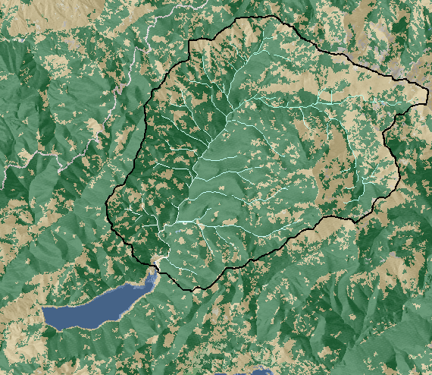

Land Cover: NLCD (2011)

|  |  |  |  |  |
| --- | --- | --- | --- | --- |
| **Vegetation Type**1 | **Fraction of watershed** | | **Mean canopy cover** | |
|  | 2001 | 2011 | 2001 | 2011 |
| Evergreen | 68.6% | 68.5% | 65% | 56% |
| Shrub | 31.4% | 31.5% | 27% | 28% |

1Other vegetation was <1% of total watershed area and converted to the two

main categories

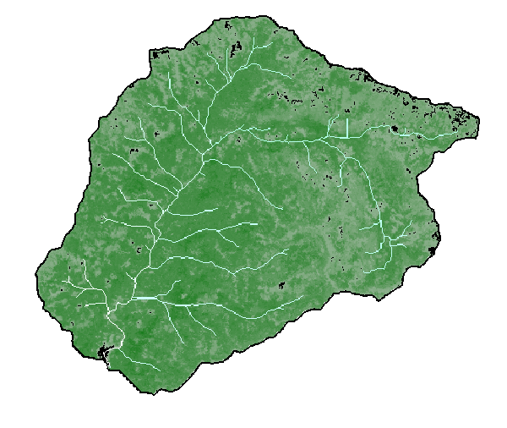

Canopy Cover: NLCD (2011)

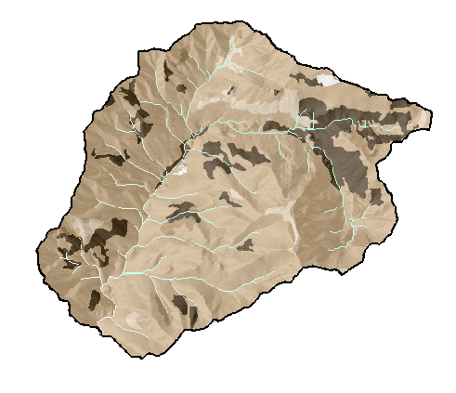

Soils - NRCS SSURGO

|  |  |
| --- | --- |
| **Soil Type** | **Fraction of watershed** |
| Sandy loam | 81.3% |
| Exposed bedrock | 12.7% |
| Loam | 1.9% |
| Water | 3.8% |
| Loamy sand | 0.3% |

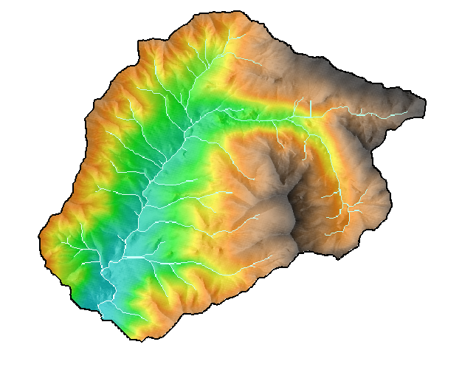

USGS 1/3 Arc-second (30 meter resolution) DEM

|  |  |
| --- | --- |
| Watershed area | 97.5 km2 |
| Elevation range | 1592-2739 m |
| Basin outlet | 4334025 N, 723650 E  (UTM 10N, NAD83, WGS84) |

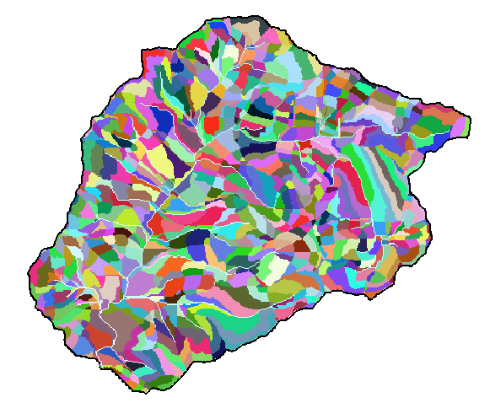

Model 1 - coarse scale

~1000 individual modeling units, takes about 10 minutes to run 38 years (2 year spinup + 1980-2015)

Advantages: fast run time, likely detailed enough for our data/uses, probably similar to SWAT Model HRU scale (although I did not specify land use/soil combos like SWAT does)

Status: Initial spin-up completed - 10 sequential runs (380 years) to stabilize Carbon, Nitrogen, & H2O values. Next step: calibration (starting with 500 random parameterizations).

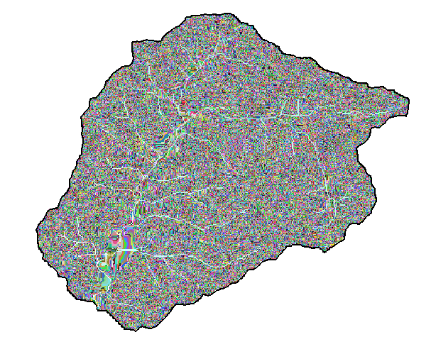

Model 2 - Fine Scale

~ 100,000 individual modeling units, takes about 12 hours to run 38 years

Advantages: May be able to directly transfer calibration from my previous American River modeling

Status: Spin-up is running now, ~40% complete and should be done by Tuesday 1/24

Meteorological input

daymet_sqv.pdf

DAYMET daily precip, tmin, tmax for pixel (1-km resolution) that overlaps the Squaw Valley met station (CDEC Station: SQV, 2554 m elevation) for 1980-2015. Could potentially input gridded met (~100 pixels).

The Squaw Valley met station has a lot of missing data, and needs a lot of processing. Will compare daily values between the two methods when I’ve completed QA on the data.

Middle Fork American River USGS Gage below French Meadows Reservoir (USGS 11427500)

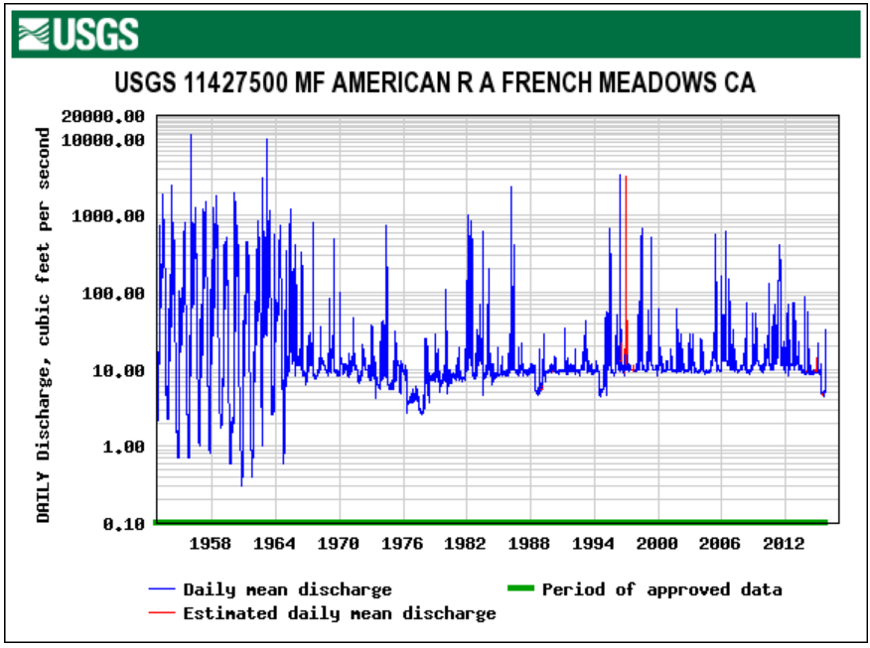

Daily discharge (1952-2016). Dam was built starting December 1964, so reservoir-free discharge data is 1952-1964. Dam wasn’t completed until 1966 (can you tell from the hydrograph?!?!), but refraining from using 1965-66 in case the stream was disturbed during construction.

Flow duration curve comparison

A first thought on how to calibrate the streamflow is to compare FDC’s for the pre-reservoir gage period and the modeled discharge period.

USGS gage: 1952-1964

RHESSys uncalibrated output (Model 1): 1980-2015

Calibration

Flow duration curves of a stream with at least 5 years of daily data represent a given stream better than any regional FDC method1.

pdf_gage_sims.pdf

Flow duration curves for the top 10 simulations as calculate by Nash-Sutcliffe Efficiency (NSE>0.99).

nse_sim.pdf

Distribution of streamflow Nash-Sutcliffe Efficiency with the range of calibration parameters used for optimization.

lognse_sim.pdf

Distribution of log-streamflow Nash-Sutcliffe Efficiency with the range of calibration parameters used for optimization.

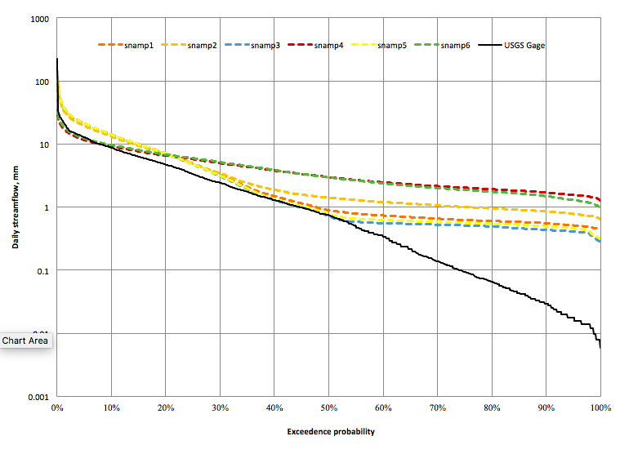

FDC results from calibrated headwater parameters (snamp1-6) and USGS Gage. Low flows are not well represented.

References

1. Castellarin, A., Galeati, G., Brandimarte, L., Montanari, A. & Brath, A. Regional flow-duration curves: Reliability for ungauged basins. *Adv. Water Resour.* **27,** 953–965 (2004).